Share Focus 11
PRODUCED BY SHARE DIRECT
Equipping You for Financial Success

20 March 2007

Contact: Warrick Selzer for more info on
Email: warricks@sharedirect.co.za

All rights reserved. No part of this e-mail may be reproduced in any form or by any means without the prior written permission of Share Direct. While every effort has been made to ensure the soundness of this e-mail, Share Direct will not bear any responsibility for the consequences for any actions based on the use of the content of this material.
World Focus

The graph of the Dow Jones Industrial Average suggests that the bull market is intact and that this is just a correction. This is not all good news if we look at the Ralph Nelson Elliott wave theory which suggests that we can see another wave down. The Fibonacci has come in very handy to point out that during the correction of June we had seen a wave down followed by the market bouncing off these lows to the 38.2% level of resistance which it could not break and then corrected another 3.4%. The Dow has recovered again only to the 38.2% Fibonacci level and found big resistance at this level. The 12 000 level is a very important level and if it does not hold this market may well correct another 3.4%.

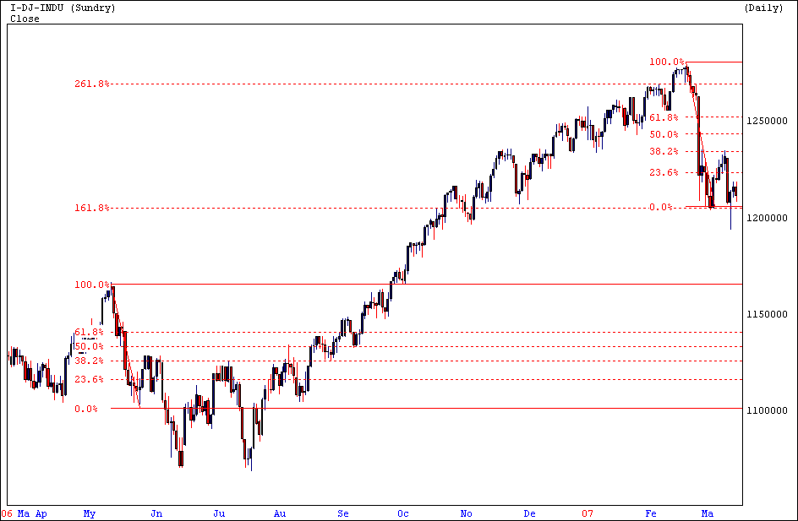

Commodity Focus

The price of Gold has been very volatile of late and the reason for this is the volatility in the Equities market and also in the Bond market. The graph of the Gold price suggests that this commodity is still in a strong upward trend. This commodity is in a bull cycle and this will have a positive effect on the Gold producers.

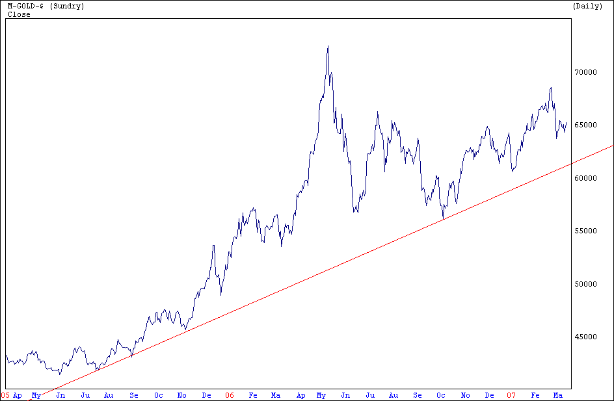

Share Focus

African Rainbow Minerals is the new addition to the top 40 shares on our market, this is an index weighted by market capatilisation which is calculated by multiplying the share price with the amount of shares of the company. African Rainbow Minerals published an excellent set of results with Headline Earnings per share up by 35.4% and retained earnings for future capital projects. The PE Ratio has improved to 21.91 and the earnings yield to 4.72.

Technically this share is in a strong upward trend. The volume graph suggests that when the volumes dry up and the price moves higher that the bulls are in control. It is a well managed company and a share to hold into the future.

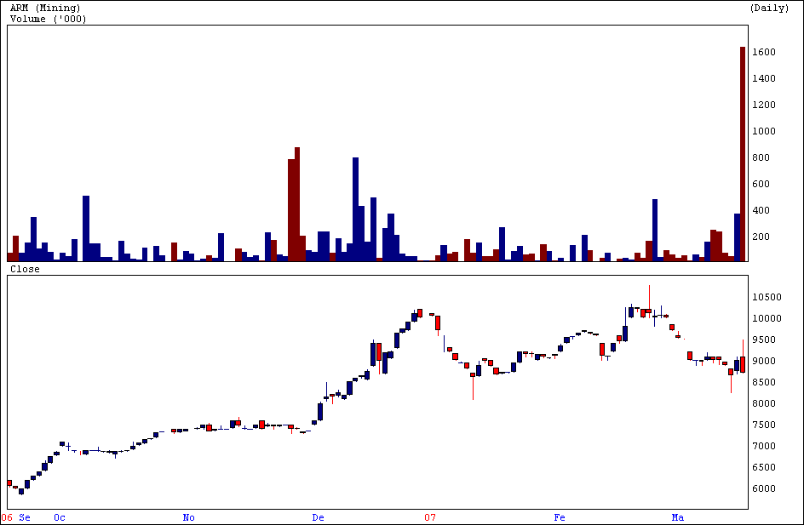

Economy Focus

The South African economy expanded by 5.6% (quarter on quarter anualised) in the forth quarter last year, well above the 4.7% forecast by the market. Strong contributions from the dominant sectors finance and manufacturing had lifted the overall performance of the economy. Third quarter growth had been revised downwards slightly, 4.7% to 4.5%. The fundamentals in our economy remain strong and this will have a positive effect on our equities market.

Good luck with trading for the week ahead! Until next time!
Sidney Launspach (B.Com Economics) Simulation Administrator

Investment Focus Club Meeting

Date: Monday 16th April 2007
Time: 18h30 – 19h30
Presenter: Ferdi Heyneke Portfolio Manager - Afrifocus
Topic: Market Overview

Members enjoy the following benefits….
- Monthly Newsletter
- SMS service: Ad hoc SMS trading recommendations & economic results will be sent to all Members.
- A Weekly Stock Market Tip
- Monthly “Investment Focus Club” Meeting
- Share Watch List
- Recorded Audio Presentations: Distance is no longer a problem
- Membership Fee: ONLY R125.00 per month!

RSVP: warricks@sharedirect.co.za
NOTE: “Complimentary” Support Meetings

FOCUS ON EDUCATION :- Alsi Workshop

presented by: Dr David Paul

Have you been caught on the wrong side of the current volatile market?
If your answer is yes, Share Direct is proud to present
The Alsi Trading Workshop.

This course will focus on:
- Risk and Reward
- Thinking of new probabilities on the Alsi.
- Money management

The trading plan will help you use different combinations of intraday technical indicators.
This trading plan details the best trading times, easy moves and biggest moves, trade entry
And exit, including the rules to master the skills of when to take the profits.

This is the perfect opportunity to get hands on practical experience utilizing these principles
and trading methods on the Alsi Intraday.

Please ensure that you bring your Laptop/PC for the day with your Share Friend Live
username and password.

Date: 4th April 2007
Time: 09h00 - 17h00
Venue: 53 Autumn Road, Aptus House, River Park, Rivonia.

Looking forward to seeing you there, becoming another highly successful investor!

PLEASE CONTACT WARRICK SELZER TO ASSIST YOU WITH YOUR ENROLMENT
Warricks@sharedirect.co.za

Please RSVP ASAP via e-mail or call me to book for any of these meetings/workshop

Should you have any further queries related to this news letter, please feel free to contact me anytime
I look forward to hearing from you.
Kind Regards,

Warrick Selzer

